|  |
| --- |
|  |
| CSE3002 – Internet and Web Programming |
| Lab – 7 |

|  |
| --- |
| Pinni Venkata Abhiram  20BAI1132 |

Q1. Company decides to give gift to the employees whose empid is a prime number. Assume that const emp array has the empid of all employees in the organization. Assume that the strength of the employee is 5. To help the HR manager write the suitable javascript code to extract the employee ids which are prime number

HTML Code

<!DOCTYPE html>

<html lang="en">

<head>

    <meta charset="UTF-8">

    <meta http-equiv="X-UA-Compatible" content="IE=edge">

    <meta name="viewport" content="width=device-width, initial-scale=1.0">

    <title>Employee filter</title>

</head>

<body style="margin: 30px; border: 2px solid;">

    <p style="padding: 20px;" class="filter1"></p>

    <script src="index.js"></script>

</body>

</html>

JS code

const empID = new Array(2,4,5,8,13);

function prime_fil(x)

{

    for (var i = 2 ; i < x ; i++)

    {

        if (x % i == 0)

        {

            return false;

        }

    }

    return true;

}

document.querySelector('.filter1').innerHTML = "Employees ID list : " + empID +"<br>" +"Employees selected for bonus are : " + empID.filter(prime_fil);

document.querySelector('.filter1').style.fontSize = "200%";

document.querySelector('.filter1').style.color = "red";

Output

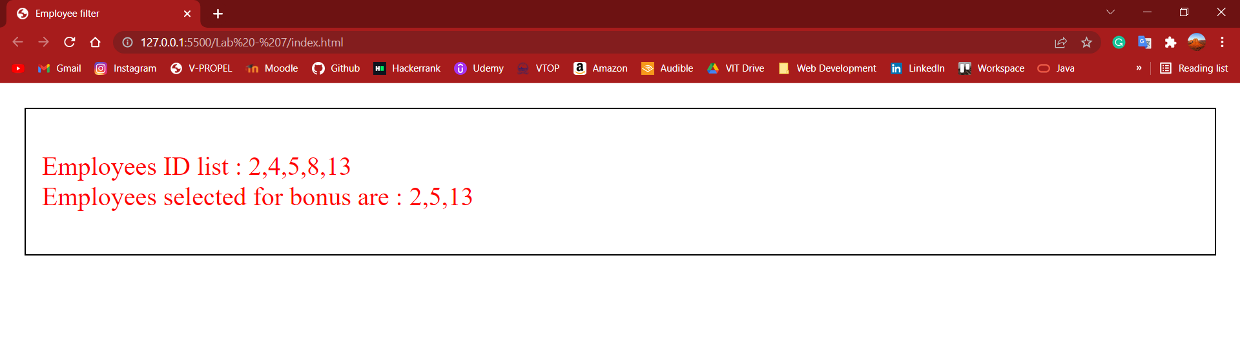

Q2. Teacher has all the students names in student array. She would like to generate a new array with students names in uppercase. Implement the suitable program using JS for this scenario

HTML Code

<!DOCTYPE html>

<html lang="en">

<head>

    <meta charset="UTF-8">

    <meta http-equiv="X-UA-Compatible" content="IE=edge">

    <meta name="viewport" content="width=device-width, initial-scale=1.0">

    <title>Teacher marks</title>

</head>

<body style="margin: 30px; border: 2px solid;">

    <p style="padding: 20px;" class="filter1"></p>

    <script src="index2.js"></script>

</body>

</html>

JS Code

const teacher_mark = ["abhiram","aronritesh","meghna","indra","rohan","akshay"]

function uppercasing(x)

{

    return x.toUpperCase();

}

document.querySelector('.filter1').innerHTML = "Names before uppercasing are : " + teacher_mark + "<br>" + "Names after uppercasing are : " + teacher_mark.map(uppercasing);

document.querySelector('.filter1').style.fontSize = "200%";

Output

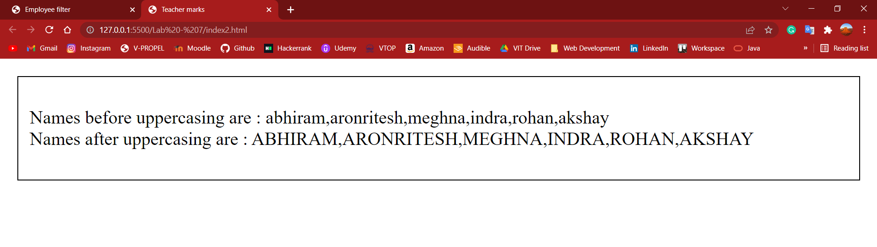

Q3. Write a JS code to sort the elements of an array a with your logic. (don’t use sort method of an array object)

HTML Code

<!DOCTYPE html>

<html lang="en">

<head>

    <meta charset="UTF-8">

    <meta http-equiv="X-UA-Compatible" content="IE=edge">

    <meta name="viewport" content="width=device-width, initial-scale=1.0">

    <title>Sort without the method</title>

</head>

<body style="margin: 30px; border: 2px solid;">

    <p style="padding: 20px;" class="filter1"></p>

    <script src="index3.js"></script>

</body>

</html>

JS Code

const nums = [3,6,7,1,2,10,9]

function array_sort(x)

{

    for (let i = 0 ;  i < x.length ; i++)

    {

        for (let j = i + 1 ; j < x.length ; j++)

        {

            if (x[i] > x[j])

            {

                let temp = x[i];

                x[i] = x[j];

                x[j] = temp;

            }

        }

    }

    return x;

}

document.querySelector('.filter1').innerHTML = "Array before sort : " + nums + "<br>" + "Array after sort : " + array_sort(nums);

document.querySelector('.filter1').style.fontSize = "200%";

Output

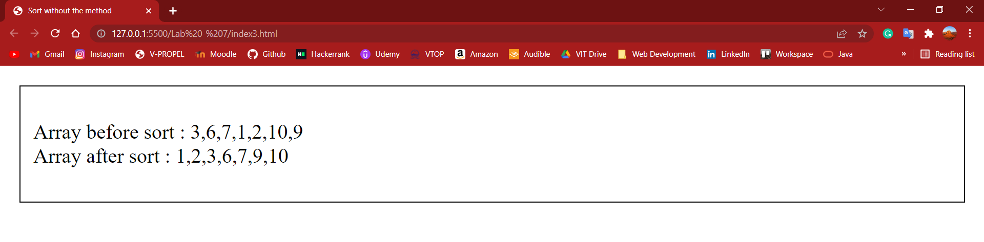

Thank you ma’am

Pinni Venkata Abhiram

20BAI1132